2013-14 NARPM® Strategic Plan
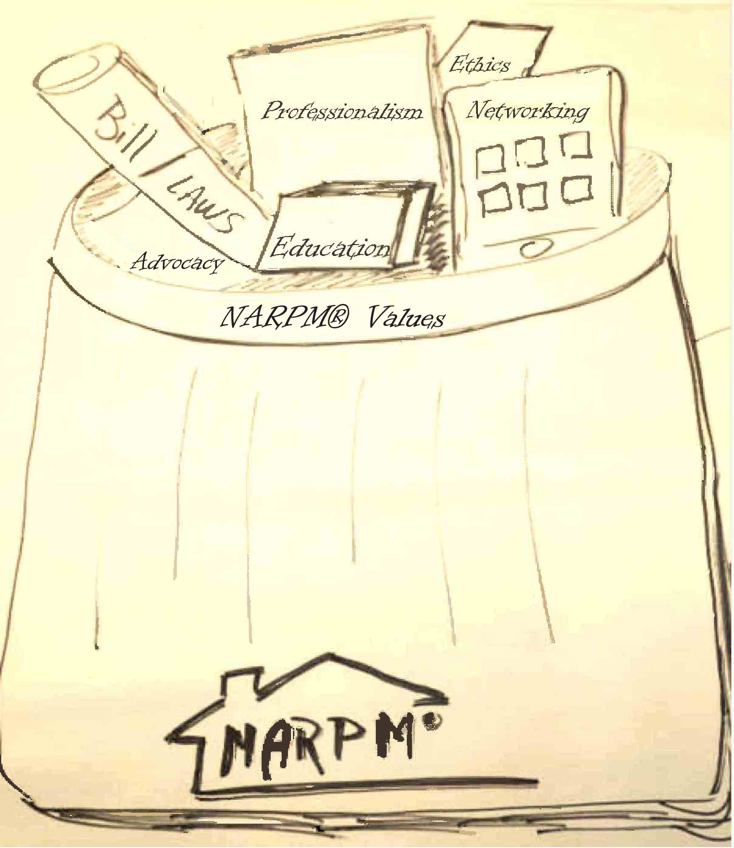

Mission: NARPM® is the professional, educational, and ethical leader for the residential property management industry.
Vision: NARPM® will be the recognized leader in residential property management

NARPM® Core Values:
Networking – Cooperation and sharing as colleagues
Education – Promotion of education and business development
Advocacy – Advance the profession by influencing issues that impact the residential property management industry
Professionalism – Recognize expertise through professional designation
Ethics- Respect and integrity among members brought about by ethical, honest and credible behavior
NARPM® Strategic Objectives and Short Term Goals:
- Reinforce the Mission and Vision of NARPM®.
- Locate and fund an advertising campaign to reevaluate the NARPM® brand
- Gather and communicate relevant Federal Legislative Issues to the membership
- Initiate and create new coalitions and alliance with similar organizations
- Develop and engaging program to entice members of the next generations

- Leadership Enhancement Initiative
  - Re-evaluate the overall nominating process
  - Identify & mentor Future Leaders
  - Charge & Delegate Staff to their highest and best use

- Ensure Organization Optimization
- Evaluate Member return on investment
- Examine Financial Impact of Programs
- Evaluate Chapter Performance

- Stay Ahead of the curve with Technology
- Annually evaluate the needs for NARPM technology
- Design Virtual Tool Box

- Maintain, Improve, and Promote Member Services (ROI)
- Improve and Expand Educational Opportunities
- Focus on improving legislative and support
- Improve quality of instructors and Presenters
- Enhance communication at all levels
- Evaluate and Improve the Designation Program
- Evaluate and Improve Membership and Services

