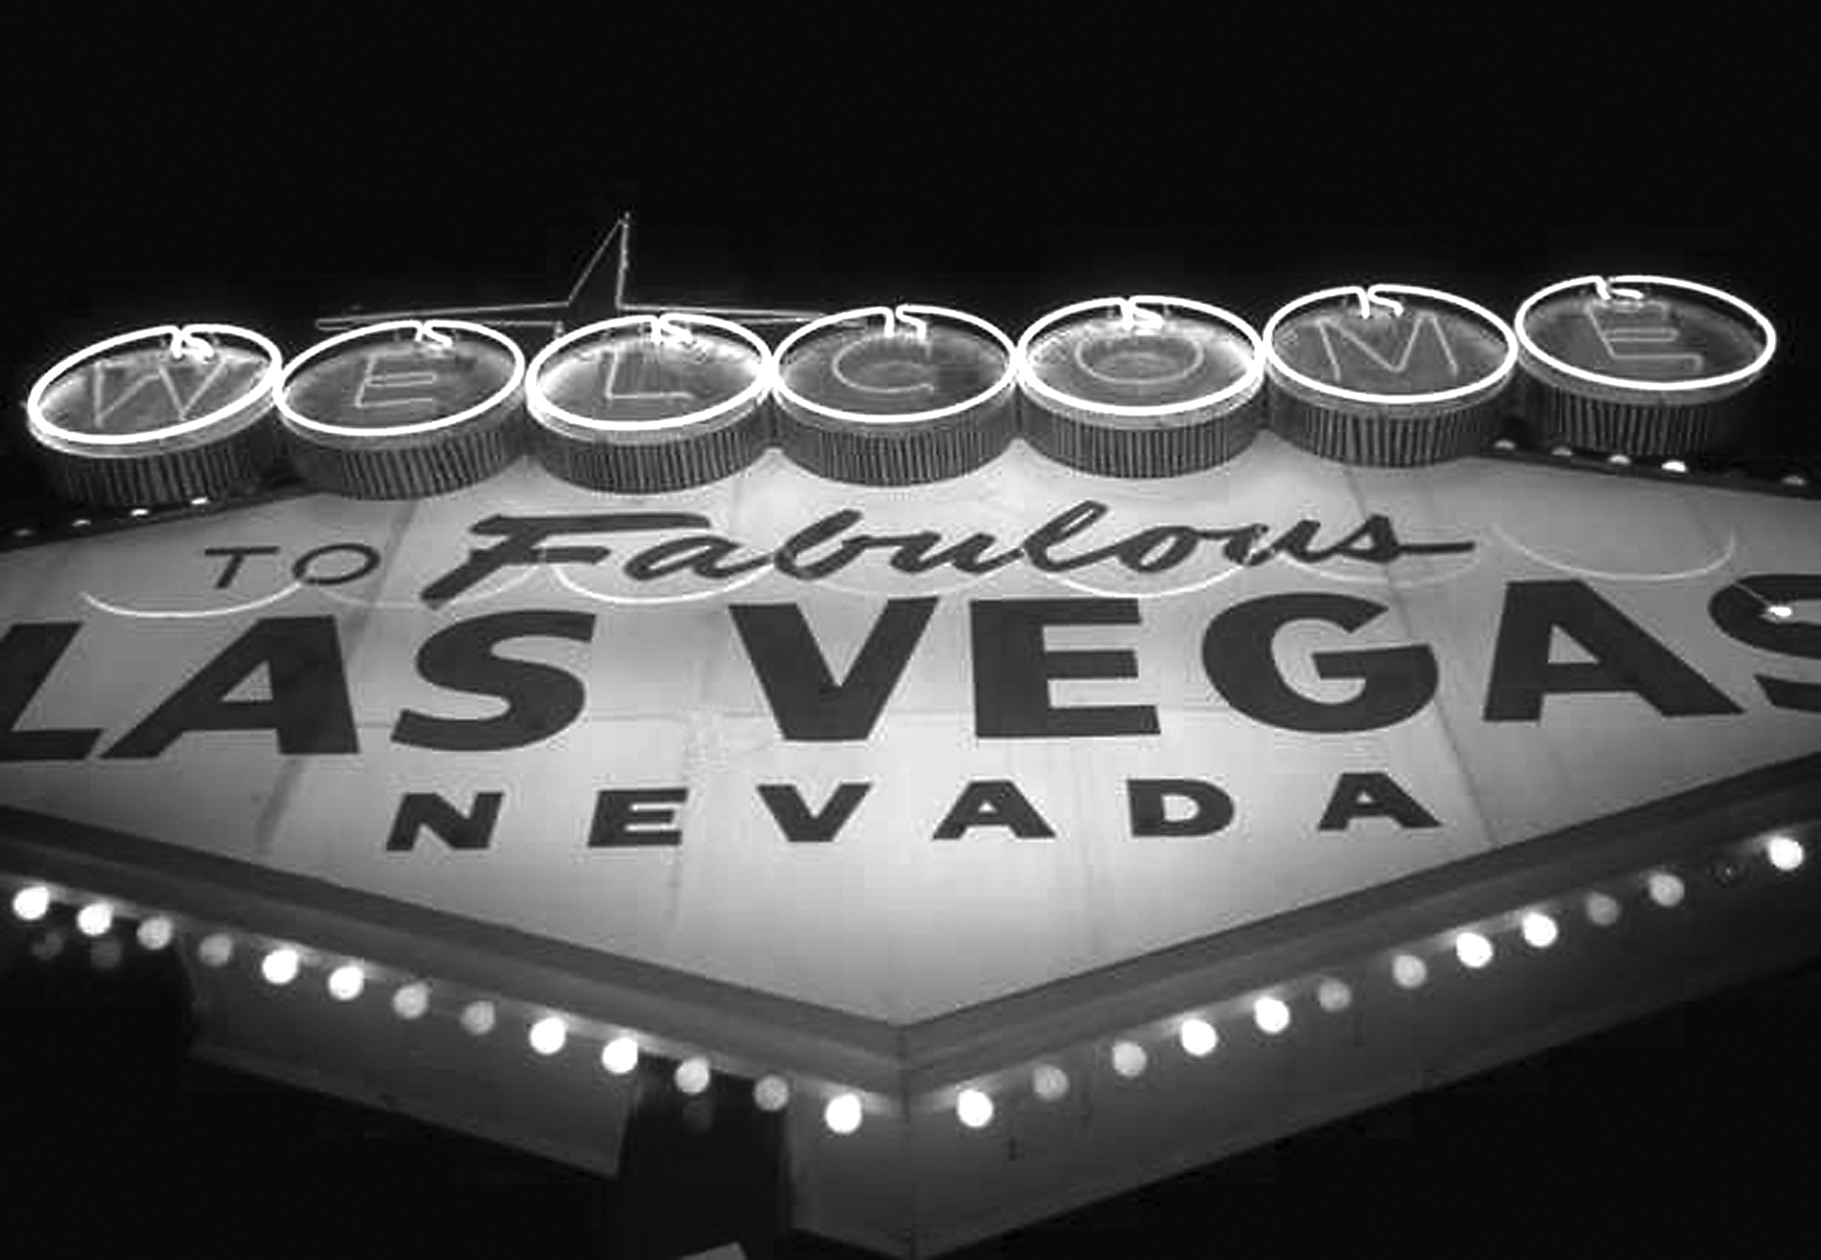
NARPM® Broker/Owner Retreat
February 21-22, 2011
Las Vegas, NV
Tuesday, February 21
8:30 AM Breakfast on your own and housekeeping Salons G - I
9:00 Microphone - Networking Session - Robert Machado, MPM® RMP® Salons G-H
Open the floor to see what people want to talk about – What would you like to accomplish during these next two days. Spend time networking with your fellow broker/owners

10:45 Form Sharing Session - Jorgette Krsulic Salons G - I
Thank you to all the members who submitted forms. Disclaimer - if you get ideas from these forms - recreate them - unethical to just use.... be sure to have your attorney review them....

12:20 Lunch Salons G - I

1:30 Marketing Your Company - Andrew Propst, MPM® RMP® Salons A-F
Learn some outstanding tips on how to effectively market your company. How to develop a marketing plan that will carry you into the future.

3:15 Round Table Sessions Salons G - I
Round table topics taken right off the Google Group discussions and discussions from the opening session (20 minutes each session)

5:00 Optional Break Outs for those who want more Salons A & F
How do you set up your company? Portfolio versus departmental which is best for your company. Robert Machado, MPM® RMP®; Mike Mumford, MPM® RMP®

Succession Planning learn from those who have been through it. Salons B & E
Rick Ebert, MPM®, RMP®; Karen Ebert, MPM® RMP®; David Holt, MPM® RMP®; Anne McCawley, MPM® RMP®; Sean Kerr, MPM® RMP®; and Debbie Smith

Exit Strategy and determining company value and actual sales process. Salons C & D
Susan Albern, MPM® RMP® and Chrysztyna Montanez, RMP®

Wednesday, February 22, 2012
8:00 Continental breakfast and housekeeping Salons G - I
9:15 Employment Issues from Attorney’s Perspective Salons A-F
Attorney Abel Ortiz, a partner in the Irvine Business and Real Estate Group, Irvine, California, will be speaking about employment issues all company owners should be aware of and the importance of following employment laws.

How to Run a Low Effort, High Profit Owner-Operator Company Steve Crossland Salon H
Strategies for the 1-3 person small office, husband/wife family, "small team" operators or burned out large operator thinking of downsizing. Topics will include how to streamline monthly tasks, create uniformity of operation, automate manual tasks, batch process recurring tasks, and act as an "Authorized Fiduciary" instead of a "Subordinate Functionary”

10:45 Working Smarter with Technology Salons G - I

Social Media - Facebook and Linked-In – Tom Fanelli with Propertyware
Google docs – Albert Oaten with Appfolio
Mobile technology - George Trombley, RMP® and Candi Swanson, MPM® RMP®

12:20 Lunch Salons G - I
Presentation from Dave Bragg, Zelman & Associates -Understanding the Single-Family Rental Industry’s Growing Piece of the Housing Pie”

1:30 Managing the Management Company Salons G - I
    - How to motivate your employees while growing your business? - Melissa Prandi, MPM® RMP®
    - How to deal with staffing issues from a Corporate prospective?. - James Wagley
    - How do you streamline maintenance so you can handle the calls? - Sylvia Hill, MPM® RMP®

330-500 Closing Event – Darnell Holloway, YELP Salons G - I
Word-of-mouth is moving online, and user generated content websites like Yelp.com are becoming increasingly powerful as consumer guides. How do you ensure your reputation is strong? No business is perfect -- how will you respond when you receive your first negative review? Everything you need to know from unlocking your free business tools to managing your online reputation.

515-615 Optional Break Out
Staffing issues can be a nightmare, how do you deal with them - James Wagley Salon H

How to evaluate and rank your employees and set up promotional opportunities in your company.
How do you move your company to the next level? Andrew Propst, MPM® RMP® Salons A – F

Thank you for attending the first NARPM® Broker/Owner Retreat
Make sure you complete your evaluation that will be emailed to you when you return to your office
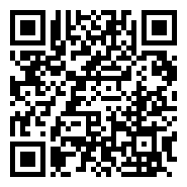

Scan the QR Code to complete survey from this event. Email will be sent at conclusion of Broker/Owner Retreat.
Scan the QR Code for handouts from this event. We will be adding more after the session.

