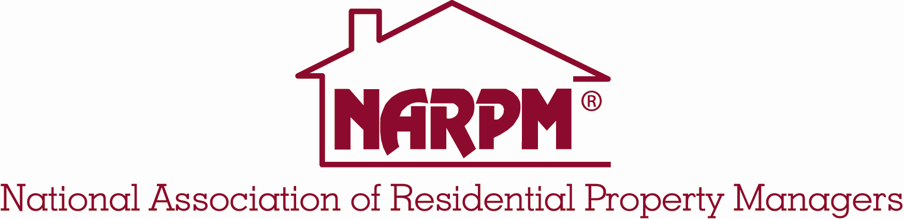

Call for Presentations NARPM® Regional Conferences

Workshops and panel presentations are being invited for the 2014 NARPM® Regional Conferences. The NARPM® Regional events boast attendance of more than 100 residential property managers at each of the four (4) regional events. The attendees include company owners, managers, executive officers, support staff, and suppliers – including those working with technology, web site, personal assistants and others. NARPM® Conference attendees want practical knowledge such as: ways to become more effective professionals; information that can be applied or tools that can be put to use; and job aids that are always popular. Theory is useful only when session participants are shown how to use it. Learning is not a passive activity. Give yourself a break–let others help do the talking. Attendees usually learn best when they are doing, not only when they are listening. Involve participants by using questions, exercises, and other activities.

Members and nonmembers of NARPM® are invited to submit proposals for Convention Presentations using this form. The professional submitting this proposal for the program is responsible for contacting all co-presenters and for all details including proposal submission, communication with co-presenters, presentation format and audio-visual requests. The Association will provide a screen and projector for sessions needing them. You must provide your own laptop for any PowerPoint presentations. The Association will determine if and what type of microphones will be used in each session. Requests for additional audio/visual equipment will be considered on a case-by-case basis.

Submission Guidelines and Information

Workshop A presentation in which a particular issue is explored in depth (1.15 hours in length)

Panel Discussion A 1.15 hour session in which a particular issue is explored by a panel with audience participation

Any other type of session you propose? (Please describe)

Fill in type of session you propose to present

Note: We reserve the right to change your presentation format and/or length, if necessary, in order to balance the convention program.

The Regional Conference Committee will review all proposals. Proposals must be typed, with all information filled out completely. The submitter must sign all submissions. Incorrect or incomplete submissions will be returned and not considered until properly submitted.

Which regional conference are you submitting your presentation for?
Western (Las Vegas) February 27 Eastern (Baltimore, MD) April 25
Central (Austin, TX) February 6-7 Northwest (Portland, OR) May 30

Fax to ___757-473-9897_____________ or e-mail to __executivedirector@narpm.org

Enter Title of Presentation: Title

Format: Workshop Panel Discussion Other

Category: Small Company Large Company Personal Development
(Check all Technology Office Procedures Legal
that apply) Tools and/or Forms Skills Management
Professional Advice Marketing

Presenter(s)

Presenter Listing: List submitter’s name first. For each presenter (maximum of 4), list name, NARPM® membership status, address, zip code, phone and fax numbers, and email address.

Enter presenter information here

Describe public speaking experience of all presenters and expertise with proposed topic:

Describe public speaking experience here

List of NARPM® board and committee positions held by each presenter to avoid schedule conflicts with meetings:

NARPM® Board/Committee positions

Has presenter(s) authored a book? If so:

Enter Title, Author, Publisher

Session

Summary of session: Limit to 250 words. Be as specific as possible about the learning that will take place at your presentation.

Summary of session

Learning objectives: List at least three learning objectives (what participants will know or will be able to do by the end of the presentation).

Learning objectives

What is new or unique about this material/topic/presentation?

New or unique ideas

Short Description of Session: This edited version will be used in the Convention program. Please include primary learning objectives. Limit to 265 characters, including spaces and punctuation.

Short Description

Presenter Contract

On my (and my co-presenters) behalf, should this proposal be selected, I (we) agree that:

- Individual submitting this proposal and signing this form agrees to receive all convention correspondence and accepts responsibility for conveying convention-related information to co-presenters.

- Unless checked at the end of this statement, NARPM® may videotape and/or audiotape this entire presentation (no partial taping), including videotape and audiotape excerpts, and distribute the tape for educational purposes. There is no honorarium or reimbursement to workshop presenter(s). Check here □ if you do not want an audiotape or videotape made of your session.

- If you are attending any other Convention sessions other than your own session, the presenter(s) is responsible for registering and paying Convention registration fees.

- Presenter must receive prior approval from NARPM® for any survey or data collection at the Regional Conferences or for any advertising/promotion/marketing of any products or services.

- It is understood that “selling” a product or service from the stage is prohibited and will result in not being accepted to speak in the future.

- Individuals submitting or included within this proposal have agreed to be present at the respective regional conference in: _____________________________________ during the time and date assigned to this presentation at the NARPM® Convention and conduct this proposed presentation according to the conditions listed above.

Agreed: Enter name here
Date: Enter date

______________________________________________________________________

National Association of Residential Property Managers
638 Independence Parkway, Suite 100
Chesapeake, VA 23320
P: 800-782-3452 | F: 866-466-2776
info@narpm.org

For information on the regional conferences go to http://www.narpm.org/conferences/index.html

