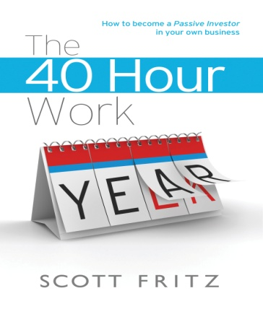

The 40 Hour Work Year
Every so often a presentation comes along that captures the attention of the hard working entrepreneur (for more than ten minutes) and literally changes the paradigm of how they view their business. You will experience Scott Fritz’s entrepreneurial journey first hand, as he shares with you the business tools, action focused exercises and mindset philosophy that allowed him to achieve The 40 Hour Work YEAR.
From the start up years with no pay, through the challenges and thrills of growing a multi-million dollar company and positioning it for sale, Scott shares his vast business experience using a matter of fact, TAKE ACTION NOW approach.
Speaking from experience is the best way to engage the entrepreneurial mind….Scott shares through his experience the action based exercises and techniques he utilized to create The 40 Hour Work YEAR.
Value to Members
YOU will learn how to:
- Build an asset, not just a business
- Remove unprofitable clients and maximize margins
- Build owner wealth and company value at the same time
- Develop simple performance metrics that maximize results
- Create decision and alignment filters for your entire organization
- Position your company to acquire other businesses or create an exit
- Develop the confidence to shift your mindset at precisely the right moment
- Create a culture where everyone is accountable for your company’s success
- Transition from working in and on your business to the role of passive investor
Scott’s

Mission: Transform the entrepreneur’s vision into action
Vision: Transition 100 business owners to Passive Investors by 2020
Values:
PASSION for everything Entrepreneurial
RESPECT for life Experiences
INGENUITY as the Filter
OPTIMISM illuminates Opportunities

*To learn more about Mr. Fritz and his programs, please visit www.40hourworkyear.com

