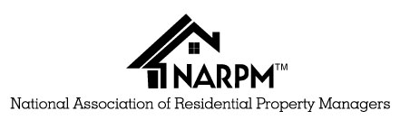

CRMC® Application for Renewal of Designation

The Certified Residential Management Company (CRMC®) designation is the highest honor NARPM grants to its membership. It is awarded to those companies which achieve the highest levels of professionalism in the residential property management industry. The companies achieving this honor are the flagships of our organization. The audit and evaluation of the companies submitting the application for the CRMC is critically important in maintaining the integrity of this designation.

Firm Name: Type of Ownership (check one): Corporation LLC Partnership Sole Proprietorship
Address: DBA’s
Designated MPM® Phone: Email:

Does this firm have multiple locations? Yes No If yes, how many locations?

Are there employees/property managers who work out of their home? Yes No
# of accounts under management:
# of property managers in the firm: # that are members of NARPM®? List each with NARPM® Designations after each name:

Please answer the following. (Use additional blank sheet, if necessary, identifying the Question prior to the continuation of your answer). Please sign and date the attached sheet(s).

1) Have there been any significant management changes since last certification or renewal? If so, please identify and give the reason for the change.

2) Has there been any change of ownership? If yes, please identify. Did ownership change more than 50%?

3) Have there been any felony convictions or license suspensions within your firm? If yes, please identify and explain.

______________ I attest that the above is a true and complete statement of facts regarding my business.

Renewal Fees: $150
Payment for Renewal fees can be paid on the NARPM website at: http://www.narpm.org/internet-member-services/
Or Mailed to: NARPM 638 Independence Pkwy, Suite 100
Chesapeake, VA 23320 Phone 800-782-3452

Printed Name of Submitting MPM®

Signature: Date:

