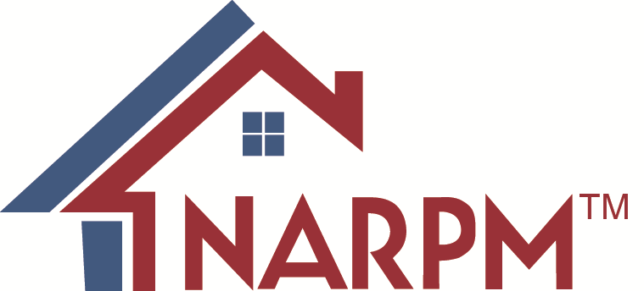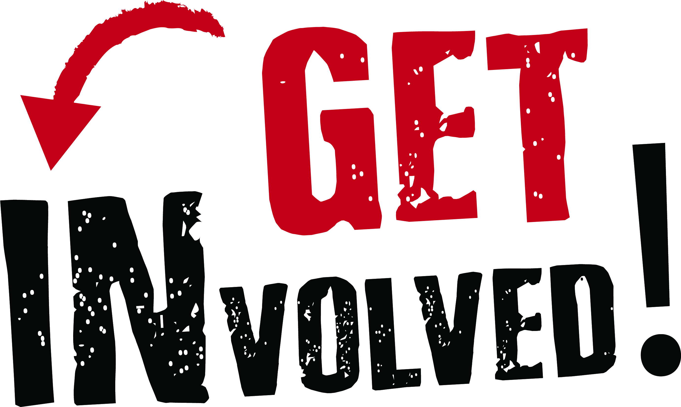

2018 Broker/Owner Conference & Expo Call for Presentations
April, 9-11, 2018

Proposed workshops/breakout sessions are now being considered for the 2018 NARPM® Broker/Owner Conference & Expo. This is the premiere event for Brokers and Owners. It is an exclusive event and attendance is limited to 600. Consider becoming a part of the rich NARPM® tradition of sharing professional and business knowledge by submitting a proposal to speak.

As you consider submitting a presentation proposal, keep in mind that NARPM® Broker/Owner Conference attendees want practical knowledge – give attendees ways to become more effective professionals, information that can be applied or tools that can be put to use, and job aids which are always popular. Theory is useful only when session participants are shown how to use it. Learning is not a passive activity. Give yourself a break – let others help do the talking. Attendees usually learn best when they are doing, not only when they are listening. Involve participants by asking questions, using exercises, and other activities.

All NARPM® members are invited to submit proposals for Conference Presentations using this form. The professional submitting this proposal for the program is responsible for contacting all co-presenters and for all details including proposal submission, communication with co-presenters, presentation format and audio-visual requests. The Association will provide a screen and projector for sessions needing them. You must provide your own laptop for any PowerPoint presentations. The Association will determine if and what type of microphones will be used in each session. Requests for additional audio/visual equipment will be considered on a case-by-case basis. Internet access in the meeting space is not provided by NARPM®. Please note: NARPM® policy states that Affiliates may not attend or speak at this NARPM® event unless they are paid exhibitors at this event.

* Proposals must be received by NARPM® no later than November 30, 2017.
* Notification of acceptance will be made no later than January 15, 2018.
Submission Guidelines and Information

Types of Breakout Sessions

Workshop A presentation in which a particular issue is explored in depth (can vary in length from 20 minutes to 1 hour, depending on event schedule, type of information presented and the discretion of the Conference Planning Committee.)

Panel Discussion A 50 minute to 1 hour session in which a particular issue is explored by a panel with audience participation (depending on event schedule, type of information presented and the discretion of the Conference Planning Committee.)

Note: We reserve the right to change your presentation format and/or length, if necessary, in order to balance the conference program. If this becomes necessary, we will contact you.

The Conference Planning Committee will review all proposals. Proposals must be typed, with all information filled out completely. This form has data entry sections to complete the information. The submitter must sign all submissions [an electronic signature is acceptable]. Submissions must also include a video clip or link to a video clip featuring the presenter speaking to a group. Incorrect, handwritten or incomplete submissions will be returned and not considered until properly submitted. NARPM® policy states that Affiliates may not attend or speak at NARPM® events unless they are paid exhibitors at that event.

On the form, enter the day and session at which you are interested in speaking. A brief description of each section is at the end of the form. E-mail to conventioninfo@narpm.org.

Enter the Title of Presentation below: This title will be used in the Registration Brochure and On-site program. Limit the title to 150 characters, including spaces and punctuation. The title should be descriptive and eye-catching. PLEASE ENTER THE TITLE IN THE FORM FILL BELOW AND CHECK THE APPROPRIATE BOXES.

Enter Session Title Here

Format: Workshop Panel Discussion Other

Category: Day One Day Two - Technology Day Three
Morning: Re-Hab Office Procedures Morning: Growth & Marketing
Afternoon: Masterminds Skills Afternoon: Risk Management
New Technology

Presenter(s) Information

Presenter Listing: List submitter’s name first. For each presenter (maximum of 4), list name, NARPM® membership status, address, zip code, phone and fax numbers, and email address.

Enter presenter name, email address and phone number here

Describe public speaking experience of all presenters and expertise with proposed topic and be sure to include a video link or clip:

Describe public speaking experience here

Session Description

Description/Summary of session: Limit to 250 words. Be as specific as possible about the learning that will take place at your presentation. This version will be edited and used in the Registration Brochure and On-site program to describe the session. Please include the primary learning objective for the session. A member of the program sub-committee will contact you do discuss the session in more depth if it is being considered.

Enter summary of session here -- a description must be entered here to be considered.

Presenter Contract

On my (and my co-presenters) behalf, should this proposal be selected, I (we) agree that:

- Individual submitting this proposal and signing this form agrees to receive all conference related correspondence and accepts responsibility for conveying conference-related information to co-presenters.

- NARPM® reserves the right to videotape and/or audiotape this entire presentation (no partial taping) and distribute the tape for sale for educational purposes. By submitting this proposal to speak you are agreeing to be video/audio taped.

- There is no honorarium or reimbursement to workshop presenter(s).

- Please note: NARPM® policy states that Affiliates may not attend or speak at NARPM® events unless they are paid exhibitors at that event.

- Provide bios, and audio/visual requests using the instructions in the Speaker Guidelines (which will be sent if your proposal is selected.)

- NARPM® requires that all handouts/presentations be provided electronically to staff by the deadline specified to be included on the Conference Micro-site so that they can be downloaded/printed by attendees prior to the conference.

- If you are attending any sessions/events other than your own session, the presenter(s) is responsible for registering and paying Conference registration fees.

- Presenter must receive prior approval from NARPM® for any survey or data collection at the Broker/Owner Conference or for any advertising/promotion/marketing of any products or services.

- It is understood that “selling” a product or service from the stage is prohibited and will result in not being accepted to speak in the future.

- Individuals submitting or included within this proposal have agreed to be present in Las Vegas during the dates of the NARPM® Conference and conduct this proposed presentation according to the conditions listed above during the specific time slot assigned by the program sub-committee.

Agreed: Enter name here -- this is your signature for the proposal
Date: Enter date

____________________________________________________________________________
SESSION DESCRIPTIONS

Day One:

The Morning will be devoted to a special session on Business Re-Hab. It will cover how to re-Hab your business, teaching the attendee how to overcome the challenges of growth, making money and how to focus on success. Topics will include, but are not limited to, risk issues, operations and growth.

The Afternoon will be a Masterminds Session and will feature a well-known business coach and will included topics that will assist the business owner in taking their business to the next level.

Day Two:

This day is devoted to issues involving technology and how technological advances can help and sometimes hurt a business.

Day Three:

The Morning will be devoted to topics covering Growth and Marketing. Topics may include such issues as acquisitions; identifying and understanding financial metrics; and marketing rental properties

The Afternoon will be devoted to Risk Management. Topics may include such topics as disaster planning and recovery and protecting your assets.

Copyright 2018, National Association of Residential Property Managers (NARPM®). All Rights Reserved.

All content, material, seminars, presentations, handouts, brochures, and all other publications (“Services”) are PROPRIETARY, PRIVILEGED, PROTECTED and OWNED by NARPM® or its approved authors. YOU ARE PROHIBITED FROM COPYING, REPRODUCING, DISTRIBUTING, MODIFYING, DISPLAYING, VIDEOTAPING, RECORDING, PUBLISHING, PERFORMING, OR TRANSMITTING ANY OF THE CONTENTS OF THE SERVICES FOR ANY PURPOSES, WITHOUT THE EXPRESS PRIOR WRITTEN CONSENT OF NARPM® AND THE AUTHOR.

THE SERVICES AND ALL CONTENT ARE PRESENTED WITH THE UNDERSTANDING THAT NARPM® AND THE AUTHORS DO NOT RENDER ANY LEGAL, ACCOUNTING, OR OTHER PROFESSIONAL SERVICE. BECAUSE OF THE RAPIDLY CHANGING NATURE OF THE LAW, INFORMATION CONTAINED HEREIN MAY BECOME OUTDATED. IN NO EVENT WILL NARPM® AND THE AUTHORS BE LIABLE FOR ANY DIRECT, INDIRECT, OR CONSEQUENTIAL DAMAGES RESULTING FROM THE USE OF THE SERVICES AND THE CONTENT THEREFROM.

National Association of Residential Property Managers
638 Independence Parkway, Suite 100
Chesapeake, VA 23320
P: 800-782-3452 | F: 866-466-2776
conventioninfo@narpm.org

