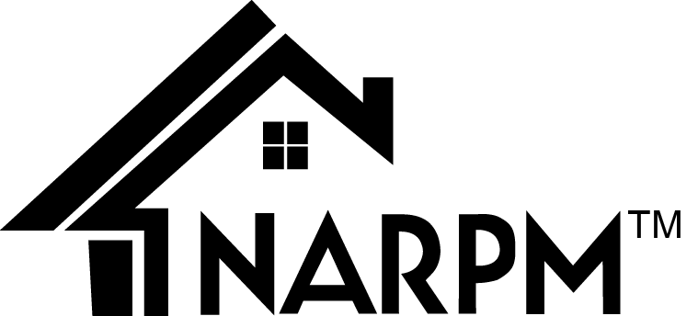2019 Washington State Conference

Sponsored By: Washington State Chapter of NARPM

Co-sponsored By: Cascade Real Estate School

Preliminary Schedule

Tuesday, April 16th

8:30 am – 9:00 am Registration
9:00 am - 4:00 pm Developing Owner Relationships, Vickie Gaskill, MPM® RMP® Instructor

Wednesday, April 17th

8:30 am – 9:00 am Registration
9:00 am – 4:00 pm Marketing for Residential Property Management, Kellie Tollifson, MPM® RMP® Instructor
1:00 pm – 4:00 pm Ethics, Chrysztyna Rowek, MPM® RMP® Instructor
6:00 pm – 9:00 pm Casino Night at the Davenport - No Host Bar

Thursday, April 18th

7:30 am – 8:00 am Registration Open
8:00 am – 9:45 am Breakfast with Speaker
9:45 am – 10:00 am Visit with the Vendors

10:00 am – 11:00 am Workshop Session 1

A 360 Degree Health Check on Your Business….............................................................……………….……… Deb Newell MPM®
Unattended Death in Your Property…………………....................................….....…......……...………………..Lesilie Lemm Baldridge

Killing the TimeThieves……………………………..........................….……………………………………………………………….…….Steve Diggs
How to Build A Property Management Supersite…………………………………………………….……………………….…….....Abi Wasserman

11:00 am – 11:15 am Visit with the Vendors

11:15 am – 12:15 pm Workshop Session 2

5 Factors Affecting Tenant Screening Policies ……………………………………………………………………………………….……Rebekah Near
Worry Free Money Life……………………………………………….........................................................………..………………Steve Diggs

Dealing With Unexpected Changes in Personnel.…….……..…..Kellie Tollifson MPM®, Melissa Sharone MPM®, Anne McCawley MPM®
5 Easy Steps to Solving Any Business Problem………………………………………………………………..………………….…Deb Newell MPM®

12:15 pm – 12:30 pm Visit with the Vendors

12:30 pm – 2:30 pm Lunch, TED TALK on Legislative Update & 50/50

2:30 pm – 2:45 pm Visit with the Vendors

2:45 pm – 3:45 pm Workshop Session 3

Focus on the Owner Interview…………………………………………………….....................................…........Chrysztyna Rowek MPM®
Great Company Cultures Don’t Happen By Accident..........................................................................……Sarah Laidler RMP®

Maintenance Nightmares.…………………………………………………............………………………………….........Ned Brandenberger RMP®

Disaster Preparedness………………….……………………………………….………………........……………………………....Simone Ramel-Mckay

3.45 pm – 4:00 pm Last chance to visit with the Vendors

4:00 pm – 5:00 pm Close of Conference, Vendor Prize Giveaways & Table Centerpiece’s

Drawing for Free Arizona 2019 NARPM National Registration

“Return On Relationships”

Get Your Chance to WIN $100 CASH

Register by March 15th

And you’ll be entered into our Special

“Early Bird Drawing”

Winner will be drawn at breakfast on April 18th

